**I-Corps**

**Quote:**

“Sometimes, it’s easy for us to get caught up in the research and not think about how the commercial impact of our science and technology can actually impact lives. Lab-Corps showed me how I can maximize the benefit of my basic research […] to create technology that has real-world commercial impacts for Americans.” Ralph Muehleisen, a researcher from Argonne National Laboratory and a graduate of Lab-Corps

**Intro:**

Developed in 2011 by the National Science Foundation (NSF), NSF Innovation Corps (I-Corps™) (hereafter [I-Corps](https://www.nsf.gov/news/special_reports/i-corps/about.jsp)) provides experiential entrepreneurship training to [teams](https://www.nsf.gov/news/special_reports/i-corps/teams.jsp) of Federally-funded researchers. I-Corps was developed to better prepare academic researchers for commercialization of federally funded research. [Grose, T. K., “[To Market, to Market](http://www.asee-prism.org/to-market-to-market-dec/)”, ASEE Prism, December 2014]. I-Corps offers an evidence-based framework to support research commercialization.  The rigorous “boot camp” curriculum emphasizes the necessity of understanding customer or stakeholder needs and in articulating a cogent value proposition in order to implement or scale an idea, technology, product, or program. “The founding concepts for the I-Corps program were informed by the extensive experience in supporting the Small Business Innovation Research (SBIR) program at NSF and the challenges we know that exist in transitioning a technology from the lab to the market,” shared Errol Arkilic, founding and former lead program director for I-Corps. [Arkilic, E., personal communication with the Policy Design Lab, January 5, 2017.]

By pairing participants with business mentors and using an intensive curriculum to help them discover a “demand-driven path” from their laboratory research to a marketable product. Rather than pushing out innovations they believe to have strong commercialization potential, participants first validate their hypotheses by sourcing feedback. By gathering strong evidence that validates their business model, participants can increase the likelihood they will build something someone cares about. “Overall, the experience relies on evidence-based decision-making. And it’s evidence that you can’t gather in a lab; you have to go to the people that are the important stakeholders in the ecosystem,” explains Lydia McClure, Program Director for I-Corps at NSF. [McClure, L., phone interview with the Policy Design Lab, July 19, 2016.]

As part of the I-Corps curriculum, researchers learn key business principles, such as:

* Commercializing a new invention requires the identification of a viable business model, not just an increase in the technological maturity of an invention
* Discovering the elements of a successful business model (e.g. value proposition, customer segments, sources of revenue) requires gathering evidence to test and refine their initial hypotheses by talking to many different potential customers and partners—leaving the lab and “getting out of the building”
* Planning and defining a prototype based on early feedback from potential customers, which reduces the time and cost associated with the commercialization process

[Sourced directly from Kalil, T., and Rockey, S. [“From Lab to Bench to Bedside: Accelerating Commercialization of Biomedical Innovations”,](https://www.whitehouse.gov/blog/2014/06/19/lab-bench-bedside-accelerating-commercialization-biomedical-innovations)  National Institutes of Health, June 19, 2014.]

See additional Toolkit content on additional applications of Lean Startup methodologies to Federal work. [[Crosslink to Lean Startup content]]

|  |
| --- |
| **Distinctions between Lean Startup, Lean LaunchPad, Hacking for Defense/Diplomacy, and I-Corps.**  I-Corps is based on the Lean LaunchPad (LLP) curriculum developed by Steve Blank and focuses on the commercialization of research. While several Federal agencies have applied I-Corps programming, others have used variants of Lean LaunchPad programming. Agency LLP programs are still considered part of the I-Corps network because of their use of the NSF’s National Innovation Network (NIN) to implement LLP in their programs. Agencies with LLP programming also still execute MOUs with NSF to access the NSF’s NIN and other resources. [McClure, L., personal communication with the Policy Design Lab, January 4, 2017.]  I-Corps has been the most structured and visible application of Lean Startup thinking into the public sector. While Lean Startup is a broader entrepreneurial methodology, the I-Corps program is one structured approach to teach the methodology and to accelerate commercialization/solution-finding. While the same foundational principles hold, one key difference is that the I-Corps formulation starts with a technology that’s seeking a market, rather than starting with a customer problem/need and iterating on a solution. [Holman, R., phone interview with Policy Design Lab, August 12, 2016.]  Hacking for Defense is another iteration of Lean Startup-related programming. In the Hacking for Defense/Diplomacy classes, Federal agencies provide universities with problems and teams of students use the same Lean LaunchPad/I-Corps method to provide solutions.) [Blank, S., personal communication with Policy Design Lab, January 5, 2017.] |

This promising approach can be deployed further to assist Departments and agencies in commercializing research as well as developing technology and tools for internal use. I-Corps programs have been adopted and adapted in partnerships with a [growing number of Federal agencies](https://www.whitehouse.gov/the-press-office/2015/08/04/fact-sheet-president-obama-announces-new-commitments-investors-companies), including the [National Institutes of Health (NIH)](https://sbir.cancer.gov/programseducation/icorps), [Department of Energy (DOE)](http://energy.gov/eere/technology-to-market/lab-corps), [Department of Defense (DOD](http://www.defense.gov/)), [National Security Agency (NSA)](https://www.nsa.gov/), [United States Department of Agriculture (USDA)](http://www.usda.gov/wps/portal/usda/usdahome), [Department of Homeland Security (DHS),](https://www.dhs.gov/) [Advanced Research Projects Agency – Energy (ARPA-E)](https://arpa-e.energy.gov/), [National Aeronautics and Space Administration (NASA)](http://sbir.gsfc.nasa.gov/content/I-Corps), and the [Small Business Administration (SBA).](https://www.sba.gov/)

To date, agency program variations have chosen to address:

* Extramural university researchers (i.e., researchers receiving Federal funding)
* Intramural researchers (e.g., research scientists at agency labs)
* Small Business Innovation Research (SBIR) and Small Business Technology Transfer (STTR) funded companies.
* on-academic technologists (i.e., alumni or community-based entrepreneurs)

**Why:**

The chief purpose of the I-Corps program is to increase entrepreneurship and the commercialization of technology that has been developed with the support of NSF-funded research.[]This is essential for increasing the economic impact of Federally-funded research and development by accelerating and improving the transfer of new technologies from the laboratory to the commercial marketplace. The Federal government invests over $ [145](https://www.whitehouse.gov/sites/default/files/omb/budget/fy2017/assets/ap_19_research.pdf) billion on research and development each year, conducted at universities, Federal laboratories, and companies; this work has yielded extraordinary long-term economic impact through the creation of new knowledge and ultimately new industries [Wynne, M., personal communication with Policy Design Lab, December 16, 2016.] Federally-funded R&D has historically led to dramatic economic growth, and there is significant potential to increase the public’s return on this investment in terms of innovation, job creation, societal impact, competitiveness, and economic prosperity [Kalil, T. and Wong, J.,“[Lab-To-Market](https://www.performance.gov/content/lab-market?view=public)”. Performance.gov]. I-Corps was designed to encourage agencies to see commercialization as an appropriate activity to support, according to Errol Arkilic, former program director for NSF I-Corps. [Arkilic, E., phone interview with Policy Design Lab, December 30, 2016.]

I-Corps is part of the *Lab to Market* Cross Agency Priority Goal, which seeks to “significantly accelerate and improve technology transfer by streamlining administrative processes, facilitating partnerships with industry, evaluating impact, and opening federal research and development (R&D) assets as a platform for innovation and economic growth.” [Kalil, T. and Wong, J., *[Lab to Market: Cross Agency Priority Goal Quarterly Progress Update, Fiscal Year 2015 Quarter 4,](https://s3.amazonaws.com/app_performance_prod_ahwdtloxcxcy/s3fs-public/Lab%20to%20Market%20FY15_Q4_1.pdf)* [Performance.gov.]](https://s3.amazonaws.com/app_performance_prod_ahwdtloxcxcy/s3fs-public/Lab%20to%20Market%20FY15_Q4_1.pdf)

**How:**

I-Corps has been an avenue for foster researching commercialization or lab-to-market initiatives. I-Corp programs facilitate evidence gathering and provides a framework for quickly responding to that evidence. While the program is highly structured, it has also been adapted to fit the specific needs at each of the agencies that have deployed I-Corps programming. The NSF has helped facilitate the launch of new I-Corps or Lean LaunchPad programs at agencies using a technique called train-the-trainer, where individuals work with the NSF-funded [National Innovation Network](https://venturewell.org/i-corps/nin/) (NIN) to adopt the I-Corps program for their constituents while ensuring the scale-up and maintenance of quality programming.

NSF is open to working with other interested agencies to develop I-Corps or Lean LaunchPad variants through a memorandum of understanding process.

How the I-Corps model works:

I-Corps Team Structure [McClure, L., personal communication with the Policy Design Lab, January 4, 2017]

The I-Corps team is typically composed of three individuals with distinct roles:

1. Entrepreneurial Lead (EL)
2. I-Corps Mentor
3. Principal Investigator (PI) / Technical Lead (TL)

The Entrepreneurial Lead (EL) could be a Post -Doctoral scholar, graduate or other student or other personnel with relevant knowledge of the technology and a deep commitment to investigate the commercial landscape surrounding the innovation. The Entrepreneurial Lead should also be capable of and have the will to support the transition of the technology, should the I-Corps project demonstrate the potential for commercial viability.

The I-Corps Mentor is typically an experienced or emerging entrepreneur with proximity to the research institution and experience in transitioning technology out of labs. The I-Corps Mentor must be a third-party resource. The I-Corps Mentor is responsible for guiding the team forward and tracking progress through regular communication with the instructors.

The Principal Investigator (PI) / Technical Lead (TL) is responsible for overall grant management and should have technical knowledge in the space.

Curriculum

The I-Corps curriculum is based on the Lean LaunchPad framework developed by Steve Blank. The program emphasizes experiential learning and Lean Startup thinking rather than learning by lecture. The canonical I-Corps model is a rigorous seven-week course, in which participants work with trainers and mentors to test how research and technologies could be commercialized by seeking input from potential customers or stakeholders. Each week, a discrete set of business hypotheses are tested by the researchers by collecting interview data from the proposed target market [“[I-Corps Curriculum](https://www.nsf.gov/news/special_reports/i-corps/curriculum.jsp)”, National Science Foundation]. Business models are developed and iteratively refined from this discovery process. By the end of the course, teams have performed at least 100 interviews with stakeholders or potential customers in their ecosystem. The results of this effort are then evaluated by the team who collectively decide whether they continue to develop and commercialize their technology, pivot and explore other market segmentation or customer fits, or suspend their commercialization effort. [McClure, L., personal communication with the Policy Design Lab, January 4, 2017.]

Instruction is provided via online platforms and through on-site activities at one of eight regional [I-Corps Nodes](http://www.nsf.gov/news/special_reports/i-corps/nodes.jsp), including:

* Southwest I-Corps
* Los Angeles I-Corps
* Upstate New York I-Corps
* [Bay Area I-Corps](http://bayicorps.com/)
* [Southern I-Corps](http://innovate.gatech.edu/programs/innovation-corps-icorps/)
* [Midwest I-Corps](http://www.michiganicorps.com/)
* [New York City Regional Innovation Node](http://www.nycrin.org/nycrin/i-corps.html)
* [DMV I-Corps](http://www.dcicorps.org/) [[Also embed pop-up spotlight content – see below]]

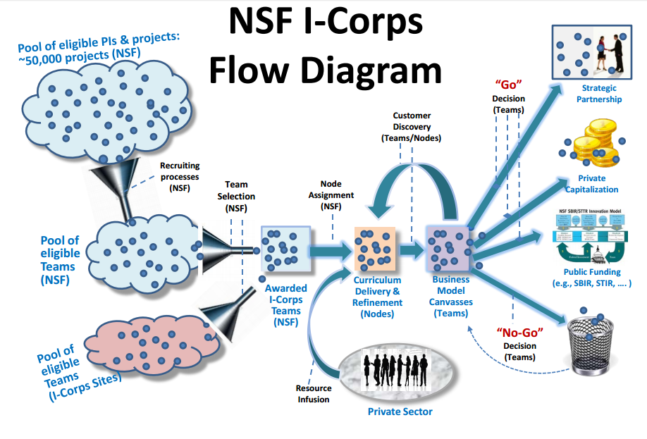

[Arkilic, E., “[Lean Startup: Lessons from the field of 300 Innovation-Corps (Lean LaunchPad) Teams](http://web.stanford.edu/group/ifarmteams/files/ErrolArkilicSlides.pdf)”, National Science Foundation]

**Case Study:**

[**National Science Foundation - I-Corps**](http://www.nsf.gov/news/special_reports/i-corps/teams.jsp)

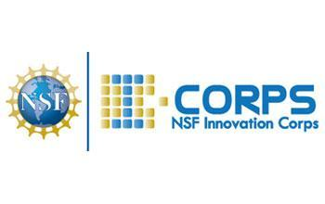[[High-res JPG available here]](http://www.nsf.gov/news/mmg/media/images/icorps_logo_h2.jpg)

**Summary:** The canonical NSF I-Corps program provides immersive education to academic engineers and scientists to help them explore the commercial viability of their technologies and form successful small business. By preparing researchers to look beyond the laboratory, it broadens the impact of NSF-funded, basic-research projects and helps to create a stronger national ecosystem for innovation.

**Key accomplishments (Impact):** The NSF I-Corps program was started in 2011 to increase the economic impact (through commercialization) of NSF-funded basic research, according to founding program director Errol Arkilic. [Arkilic, E., phone interview with Policy Design Lab, December 30, 2016.] Since then, NSF has increased the annual I-Corps program budget from $2M in FY2011 to $30 million in FY2017, held 44 cohorts, worked with 950 teams of 2900 individuals through the national I-Corps program, and created a National Innovation Network of over 70 universities that has taught a version of the I-Corps curriculum to tens of thousands of researchers. [McClure, L., personal communication with the Policy Design Lab, January 4, 2017.]As the NIN expands, the applicability of the I-Corps curriculum has found utility outside of academic institutions; NIN works with both academic and non-academic researchers and entrepreneurs. [McClure, L., personal communication with the Policy Design Lab, January 4, 2017.]

The impact of I-Corps is measured at the level of the institution, individual, and company, explains Lydia McClure. [McClure, L., personal communication with the Policy Design Lab, January 4, 2017.] I-Corps expects NIN to impact culture change at the academic institutions by encouraging entrepreneurial curricula to be incorporated in the classroom, entrepreneurship activity to be recognized and supported by the institution and individual research labs, and intellectual property licensed to new startups. The accelerator model of I-Corps allows individual assessment of participants in their entrepreneurial self-efficacy and career trajectory. Lastly, startup success metrics can be measured as the research is transferred to industry in license revenue, jobs created, sales revenue, private funding raised, etc.

**How they did it:**

As the founding agency for the SBIR program and with deep relationships in supporting basic research, NSF had extensive experience in the challenges of transition research to commercial applications. They relied on this experience and sought guidance from established entrepreneurs to develop a targeted curriculum where I-Corps participants could learn to identify valuable product opportunities that can emerge from NSF-supported academic research.

NSF relied on a quick-turn, internal-review for proposals and limited their size to $50,000. The founding principle was to quickly provide small catalytic funds on a quarterly cycle; the near continuous cycle allowed teams to explore the commercial potential on concepts as they emerged from the lab. [Arkilic, E., personal communication with the Policy Design Lab, January 5, 2017.] Innovation opportunities do not conveniently present themselves on yearly grant cycles, Founding program director Errol Arkilic remarked. [Arkilic, E., personal communication with the Policy Design Lab, January 5, 2017.]

**How it works:**

With guidance from established entrepreneurs and through a targeted curriculum, I-Corps participants learn to identify valuable product opportunities that can emerge from NSF-supported academic research. Over a period of six months, each team learns what it will take to achieve an economic impact with their particular innovation.

**Read more:**

[From Science Lab to Startup](https://www.whitehouse.gov/blog/2012/08/10/nsf-innovation-corps-science-lab-startup)

[FY17 NSF budget (provides program scope)](https://www.nsf.gov/about/budget/fy2017/pdf/38_fy2017.pdf)

**Next Steps/Checklist:**

**Relevant Policies:**

**Additional Resources:**